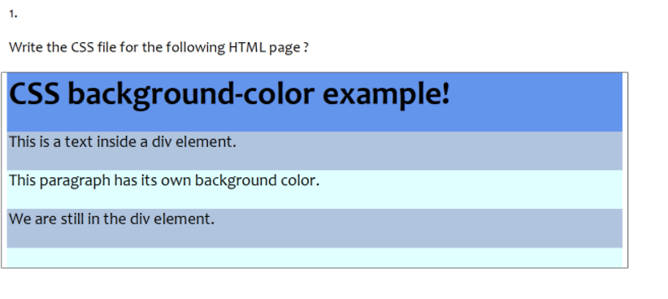

<!DOCTYPE html>

<html>

    <head>

        <style>

            h1{

                background-color:#2166a3;

            }

            div{

                background-color:lightgrey;

            }

            p{

                background-color:lightblue;

            }

        </style>

    </head>

    <body>

        <h1>CSS background-color example!</h1>

        <div>

            This is a test inside a div element.

            <p> This paragraph has its own background color.</p>

            We are still in the div element.

        </div>

    </body>

</html>

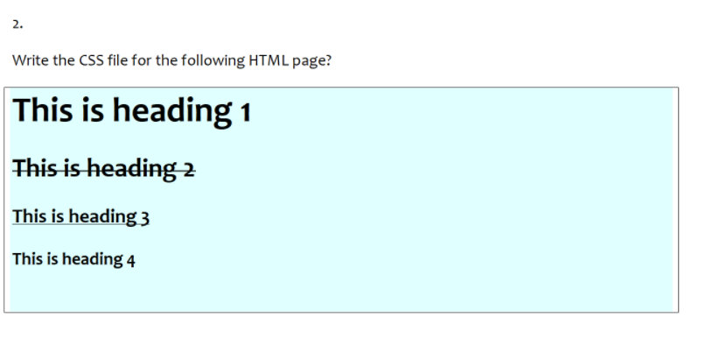

<!DOCTYPE html>

<html>

    <head>

        <style>

            body{

                background-color:#ccebff;

            }

            h2{

                text-decoration:line-through;

            }

            h3{

                text-decoration:underline;

            }

        </style>

    </head>

    <body>

        <h1>This is heading 1</h1>

        <h2>This is heading 2</h2>

        <h3>This is heading 3</h3>

        <h4>This is heading 4</h4>

    </body>

</html>

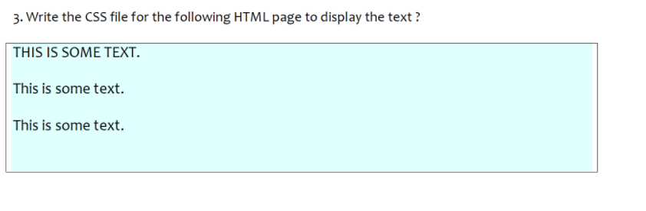

<!DOCTYPE html>

<html>

    <head>

        <style>

            body{

                background-color:#ccebff;

            }

        </style>

    </head>

    <body>

        <h2>THIS IS SOME TEXT.</h1>

        <h3>This is some text.</h2>

        <h4>This is some text.</h3>

    </body>

</html>

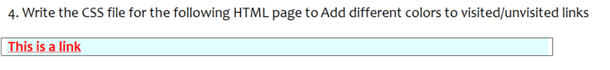

<!DOCTYPE html>

<html>

    <head>

        <style>

            body{

                background-color:#87ceeb;

            }

            /*Unvisited link*/

            a:link{

                color:red;

            }

            /*visited link*/

            a:visited{

                color:yellow;

            }

        </style>

    </head>

    <body>

        <p><a href="default.asap" target="_blank">This is a link</a></p>

    </body>

</html>

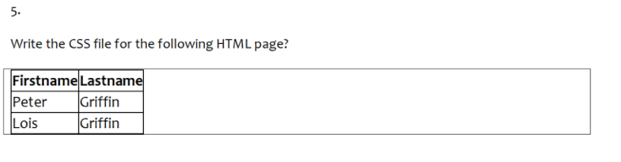

<!DOCTYPE html>

<html>

   <head>

       <style>

           table,td,th{

               border:1px solid black;

           }

           table{

               border-collapse:collapse;

           }

       </style>

   </head>

   <body>

       <table>

        <tr>

            <th>Firstname</th>

            <th>Lastname</th>

        </tr>

        <tr>

            <td>Peter</td>

            <td>Griffin</td>

        </tr>

<tr>

         <td>Lois</td>

         <td>Griffin</td>

</tr>

       </table>

   </body>

</html

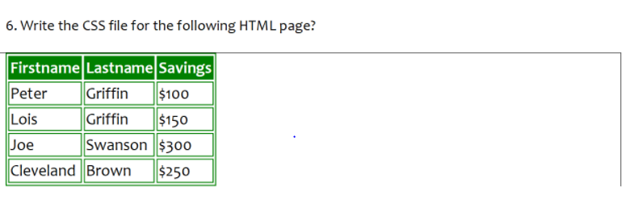

<!DOCTYPE html>

<html>

   <head>

       <style>

           table,td,th{

               border:2px solid black;

               border-color:green;

           }

           table{

               border-color:green;

               border:1px solid black;

           }

           th{

               background-color:green;

           }

       </style>

   </head>

   <body>

       <table>

        <tr>

            <th>Firstname</th>

            <th>Lastname</th>

            <th>Savings</th>

        </tr>

        <tr>

            <td>Peter</td>

            <td>Griffin</td>

            <td>$100</td>

        </tr>

        <tr>

            <td>Lois</td>

            <td>Griffin</td>

            <td>$150</td>

        </tr>

        <tr>

            <td>Joe</td>

            <td>Swanson</td>

            <td>$300</td>

        </tr>

        <tr>

            <td>Cleveland</td>

            <td>Brown</td>

            <td>$250</td>

        </tr>

       </table>

   </body>

</html

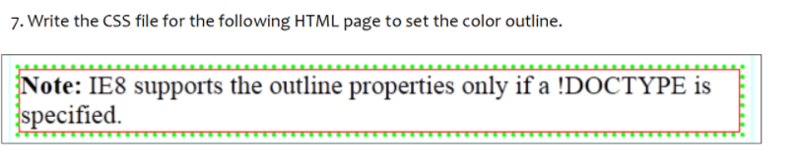

<!DOCTYPE html>

<html>

    <head>

        <style>

            p{

                border:dotted green;

            }

            div{

                border:1px solid red;

            }

        </style>

    </head>

    <body>

            <p><div><b>Note:</b>IE8 supports the outline properties only if a !DOCTYPE is specified.</div></p>

    </body>

</html>

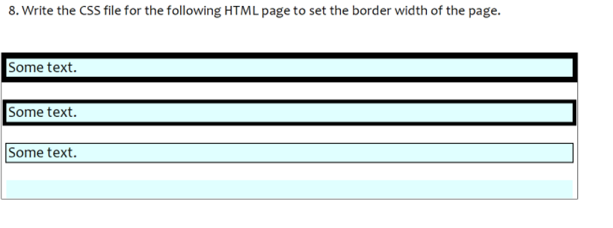

<!DOCTYPE html>

<html>

    <head>

        <style>

            p1{

                border:4px solid black;

                background-color:#87ceeb;

            }

            p2{

                border:3px solid black;

                background-color:#87ceeb;

            }

            p3{

                border:1px solid black;

                background-color:#87ceeb;

            }

        </style>

    </head>

    <body>

        <p1>some text</p1><br><br>

        <p2>some text</p2><br><br>

        <p3>some text</p3>

    </body>

</html>